Comparative Analysis of Deep Learning Architectures for Pneumonia Detection from Chest X-Ray Images

Synopsis
Deep Learning Project
[ICT-4442]

Submitted By

Tanushree Ashok Hegde-210953381.
Sathwik-220953008.



SCHOOL OF COMPUTER ENGINEERING
MANIPAL INSTITUTE OF TECHNOLOGY,
MANIPAL ACADEMY OF HIGHER EDUCATION

October 2026
Abstract
Pneumonia is a common respiratory condition in which chest X-ray (CXR) imaging is frequently used as part of clinical assessment. Deep learning has been widely investigated for automated analysis of chest radiographs because convolutional neural networks (CNNs) and transformer-based architectures can learn discriminative visual features directly from images. This project studies the use of multiple deep learning architectures for binary pneumonia classification from chest X-ray images. The proposed architecture set consists of a Custom CNN, ResNet50, DenseNet121, and Vision Transformer (ViT).
For the current Phase 2/interim stage, the Kermany-associated Chest X-Ray Images (Pneumonia) dataset was acquired and organized into training, validation, and test directories containing NORMAL and PNEUMONIA classes. A common 224×224 preprocessing pipeline was implemented, with training-time augmentation and appropriate normalization. Two models—Custom CNN and transfer-learning ResNet50—have been implemented and evaluated on the fixed test set. The preliminary Custom CNN achieved 88.94% accuracy, 87.59% precision, 95.90% recall, 91.55% F1-score for the PNEUMONIA class, and 95.44% ROC-AUC. The frozen-base ResNet50 baseline achieved 71.79% accuracy, 69.18% precision, 98.97% recall, 81.43% PNEUMONIA F1-score, and 92.58% ROC-AUC.
These results are preliminary and were obtained before extensive hyperparameter optimization or fine-tuning. They are therefore used to validate the pipeline and establish baselines rather than to claim clinical performance. DenseNet121 and Vision Transformer remain to be integrated into the common evaluation framework, followed by controlled tuning, comparative analysis, explainability/visualization where feasible, and final documentation.
1. Introduction
Chest X-rays are widely used for evaluating thoracic conditions, including pneumonia. Manual interpretation requires clinical expertise, and the appearance of pneumonia can vary with patient age, disease type, disease severity, image quality, and acquisition conditions. Deep learning offers a computer-vision approach in which a model learns image representations from labeled examples rather than relying only on manually engineered features.
Research in this area has progressed from conventional CNN classifiers and transfer learning to ensembles, attention mechanisms, and Vision Transformers. Kermany et al. demonstrated image-based deep learning for medical diagnosis using pediatric chest radiographs, while CheXNet showed the potential of DenseNet-based learning on a much larger multi-disease chest X-ray dataset. More recent work has explored transformer architectures and hybrid attention systems. Reviews published in 2022 and 2026 also highlight generalization, dataset bias, interpretability, and external validation as continuing challenges.
The objective of this project is not to build a clinical diagnostic system. Instead, it is an academic comparative study that implements different deep learning families under a common experimental setup and analyzes how their learning behavior and evaluation metrics differ.
2. Problem Statement
To design and experimentally compare deep learning architectures capable of classifying chest X-ray images into NORMAL and PNEUMONIA categories, using a consistent dataset, preprocessing strategy, evaluation protocol, and set of classification metrics.
3. Objectives
Acquire and organize a labeled chest X-ray dataset suitable for binary pneumonia classification.
Perform image inspection, class-distribution analysis, corruption checks, resizing, normalization, and training-time augmentation.
Implement a Custom CNN as a lightweight baseline.
Implement ResNet50 using ImageNet transfer learning as a second baseline.
Implement DenseNet121 and Vision Transformer in the next project stage.
Evaluate models using accuracy, precision, recall/sensitivity, F1-score, ROC-AUC, loss, and confusion matrices.
Compare the models under a common test protocol and discuss strengths, limitations, and error patterns.
Maintain reproducible project artifacts, code, results, contribution records, and a final timeline.
4. Literature Review
The literature indicates that pneumonia detection from chest X-rays has been investigated using CNNs, transfer learning, ensembles, attention-based networks, and transformer architectures. The reported metrics below should not be interpreted as directly comparable because the studies use different datasets, class definitions, splits, preprocessing pipelines, and evaluation protocols.
Paper | Method | Dataset | Key result / observation | Relevance
1. Kermany et al. (2018) | Image-based deep learning for medical diagnosis | Pediatric chest X-rays; NORMAL/PNEUMONIA | Demonstrated strong automated classification performance and established a widely reused pediatric pneumonia dataset. | Provides the primary dataset context for this project.
2. Rajpurkar et al. (2017), CheXNet | 121-layer DenseNet trained on ChestX-ray14 | ChestX-ray14; >100k frontal CXR images; 14 diseases | Reported radiologist comparison using F1-score for pneumonia and extended the model to 14 thoracic findings. | Motivates DenseNet121 and transfer learning.
3. Liang & Zheng (2020) | Transfer learning with deep residual network and dilated convolution | Pediatric pneumonia CXR dataset | Used residual learning and dilated convolution to address feature-resolution and deep-network issues. | Supports the use of ResNet-style architectures for pediatric pneumonia.
4. Kundu et al. (2021) | Weighted ensemble of GoogLeNet, ResNet-18 and DenseNet-121 | Kermany and RSNA pneumonia datasets | Reported 98.81% accuracy / 98.80% sensitivity on Kermany and 86.85% accuracy / 87.02% sensitivity on RSNA using five-fold CV. | Shows the impact of architecture ensembles and dataset choice.
5. Wang et al. (2021) | Deep-learning pipeline for pneumonia/COVID-19 discrimination | Heterogeneous multicentre dataset; 145,202 images | Reported AUC values of 0.94–0.98 for several classification tasks and evaluated across multiple cohorts. | Highlights the importance of heterogeneous data and external testing.
6. Usman, Zia & Tariq (2022) | Transfer learning with Vision Transformer vs CNN baselines | CheXpert and pediatric pneumonia datasets | Found evidence that pretrained ViT representations can transfer effectively to medical chest radiography tasks. | Provides direct motivation for the proposed ViT model.
7. Wang et al. (2023), PneuNet | ResNet18 + channel-based multi-head attention inspired by ViT | CXR datasets including COVID-19/pneumonia categories | Reported 94.96% accuracy for three-category classification and 99.30% for a binary setting in the reported experiments. | Shows a hybrid CNN/attention direction relevant to transformer comparison.
8. Singh et al. (2024) | Vision Transformer for pneumonia detection | Public CXR dataset from Mendeley/Kaggle | Reported 97.61% accuracy, 95% sensitivity and 98% specificity in the study's experimental setting. | Provides a recent ViT benchmark and motivates transformer evaluation.
9. An, Chen & Shao (2024) | EfficientNetB0 + DenseNet121 with multi-head self-attention | Chest X-ray pneumonia dataset | Proposed an attention-enhanced ensemble for pneumonia classification using pretrained feature extractors. | Supports comparison of DenseNet and attention-based feature learning.
10. Matsuo et al. (2026) | Review of AI for chest radiography | Review of CXR AI literature | Identifies progress from CNNs to transformers and multimodal systems while emphasizing bias, generalization and explainability challenges. | Provides current research context and project limitations.

4.1 Research Gap
Reported performance is highly dependent on dataset composition, train/test split, preprocessing, and evaluation protocol, so cross-paper numbers are difficult to compare directly.
Many studies focus on a single architecture or use complex ensembles, while a controlled student-scale comparison of a lightweight Custom CNN, ResNet50, DenseNet121, and ViT on the same dataset can provide a clearer architectural comparison.
High test performance on a public dataset does not by itself establish robustness across hospitals, devices, populations, or clinical settings.
Explainability and error analysis are increasingly important for medical imaging systems and will be considered in the final stage where computationally feasible.
5. Dataset Acquisition and Description
The primary dataset used in this project is the Chest X-Ray Images (Pneumonia) dataset associated with the work of Kermany et al. The commonly distributed version contains 5,856/approximately 5.8k JPEG images organized into train, validation, and test folders, with NORMAL and PNEUMONIA classes. The project uses the directory structure supplied by the dataset rather than creating a new random split at this stage.
Dataset source used for acquisition: Kaggle – Chest X-Ray Images (Pneumonia), based on the Kermany dataset. The underlying academic reference is Kermany et al., Cell, 2018.
Split | Class | Images
Train | NORMAL | 1,341
Train | PNEUMONIA | 3,875
Validation | NORMAL | 8
Validation | PNEUMONIA | 8
Test | NORMAL | 234
Test | PNEUMONIA | 390
Total | NORMAL | 1,583
Total | PNEUMONIA | 4,273
Total | All | 5,856

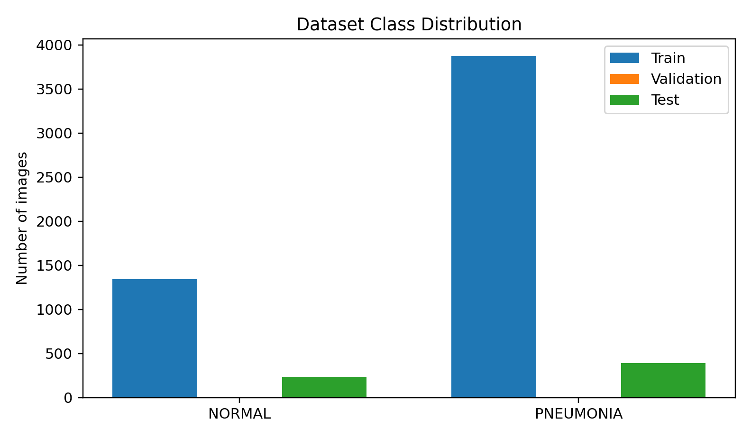
Figure 1. Class distribution across the train, validation, and test splits.
5.1 Dataset Inspection
Verified the expected train/validation/test directory hierarchy.
Verified NORMAL and PNEUMONIA class folders.
Inspected image dimensions, file formats, and image modes.
Checked for unreadable/corrupted images before model training.
Visualized representative images from both classes.
Observed class imbalance in the training data, with PNEUMONIA images substantially more numerous than NORMAL images.
6. Data Preprocessing Pipeline
A common preprocessing pipeline was implemented to ensure that the models receive images in a consistent form. All images are resized to 224×224 pixels. For the Custom CNN, pixel values are rescaled to [0,1]. For ResNet50, the Keras ResNet50 preprocess_input function is used after augmentation. Training augmentation is applied only to the training dataset; validation and test data remain unaugmented.
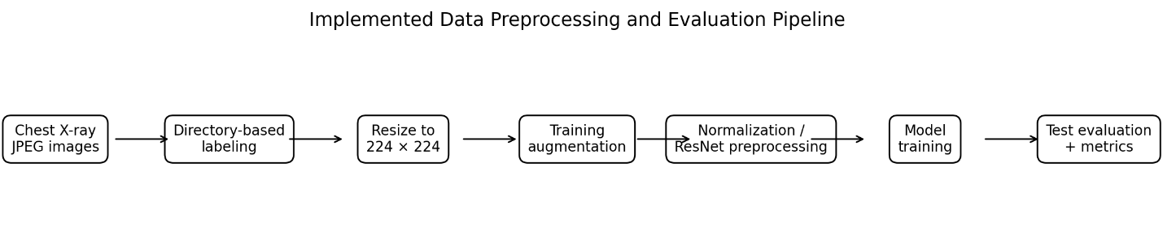
Figure 2. Implemented preprocessing and evaluation pipeline.
Parameter | Setting | Purpose
Image size | 224 × 224 × 3 | Standard input size for both implemented architectures.
Batch size | 32 | Used for training and evaluation.
Label mode | Binary | NORMAL = 0, PNEUMONIA = 1.
Random seed | 42 | Supports repeatable dataset ordering/augmentation behavior.
Training augmentation | Horizontal flip, rotation 0.05, zoom 0.10 | Applied only to training data.
Normalization | Rescaling 1/255 | Used by Custom CNN.
ResNet preprocessing | resnet50.preprocess_input | Used for ResNet50 input preparation.
Prefetching | tf.data.AUTOTUNE | Improves input pipeline efficiency.

6.1 Preprocessing Code
import tensorflow as tf
IMG_SIZE = (224, 224)
BATCH_SIZE = 32
SEED = 42
train_ds = tf.keras.utils.image_dataset_from_directory(
"../dataset/chest_xray/train",
image_size=IMG_SIZE,
batch_size=BATCH_SIZE,
label_mode="binary",
shuffle=True,
seed=SEED
)
val_ds = tf.keras.utils.image_dataset_from_directory(
"../dataset/chest_xray/val",
image_size=IMG_SIZE,
batch_size=BATCH_SIZE,
label_mode="binary",
shuffle=False
)
test_ds = tf.keras.utils.image_dataset_from_directory(
"../dataset/chest_xray/test",
image_size=IMG_SIZE,
batch_size=BATCH_SIZE,
label_mode="binary",
shuffle=False
)
data_augmentation = tf.keras.Sequential([
tf.keras.layers.RandomFlip("horizontal"),
tf.keras.layers.RandomRotation(0.05),
tf.keras.layers.RandomZoom(0.10)
])
AUTOTUNE = tf.data.AUTOTUNE
train_ds = train_ds.prefetch(AUTOTUNE)
val_ds = val_ds.prefetch(AUTOTUNE)
test_ds = test_ds.prefetch(AUTOTUNE)
7. Model 1 – Custom CNN
The Custom CNN is the lightweight baseline architecture. It learns hierarchical image features using three convolutional blocks, followed by a fully connected classifier. Dropout is included to reduce overfitting. Data augmentation and rescaling are incorporated into the model pipeline.
Component | Configuration
Input | 224×224×3
Conv block 1 | Conv2D 32 + ReLU + MaxPooling
Conv block 2 | Conv2D 64 + ReLU + MaxPooling
Conv block 3 | Conv2D 128 + ReLU + MaxPooling
Classifier | Flatten → Dense 128 ReLU → Dropout 0.5
Output | Dense 1 Sigmoid
Optimizer | Adam, learning rate 0.0001
Loss | Binary cross-entropy
Training control | Early stopping + best-model checkpoint
Maximum epochs | 15

model = tf.keras.Sequential([
data_augmentation,
tf.keras.layers.Rescaling(1./255),
tf.keras.layers.Conv2D(32, 3, activation="relu"),
tf.keras.layers.MaxPooling2D(),
tf.keras.layers.Conv2D(64, 3, activation="relu"),
tf.keras.layers.MaxPooling2D(),
tf.keras.layers.Conv2D(128, 3, activation="relu"),
tf.keras.layers.MaxPooling2D(),
tf.keras.layers.Flatten(),
tf.keras.layers.Dense(128, activation="relu"),
tf.keras.layers.Dropout(0.5),
tf.keras.layers.Dense(1, activation="sigmoid")
])
model.compile(
optimizer=tf.keras.optimizers.Adam(learning_rate=1e-4),
loss="binary_crossentropy",
metrics=[
"accuracy",
tf.keras.metrics.Precision(name="precision"),
tf.keras.metrics.Recall(name="recall")
]
)
8. Model 2 – ResNet50 Transfer Learning
ResNet50 is a deep residual CNN pretrained on ImageNet. In the current preliminary experiment, the convolutional base is frozen and only a new binary classification head is trained. This establishes a transfer-learning baseline before any fine-tuning.
Component | Configuration
Backbone | ResNet50, include_top=False
Pretrained weights | ImageNet
Backbone trainable? | No – frozen for baseline
Input | 224×224×3
Preprocessing | tf.keras.applications.resnet50.preprocess_input
Pooling | GlobalAveragePooling2D
Regularization | Dropout 0.4
Output | Dense 1 Sigmoid
Optimizer | Adam, learning rate 0.0001
Training control | Early stopping + best-model checkpoint
Maximum epochs | 10

base_model = tf.keras.applications.ResNet50(
include_top=False,
weights="imagenet",
input_shape=(224, 224, 3)
)
base_model.trainable = False
inputs = tf.keras.Input(shape=(224, 224, 3))
x = data_augmentation(inputs)
x = tf.keras.applications.resnet50.preprocess_input(x)
x = base_model(x, training=False)
x = tf.keras.layers.GlobalAveragePooling2D()(x)
x = tf.keras.layers.Dropout(0.4)(x)
outputs = tf.keras.layers.Dense(1, activation="sigmoid")(x)
model = tf.keras.Model(inputs, outputs)
9. Preliminary Experimental Results
Both implemented models were evaluated on the same 624-image test set. The test set contains 234 NORMAL and 390 PNEUMONIA images. The reported results are from the current preliminary/unoptimized experiments.
Model | Accuracy | Precision | Recall | F1-score | ROC-AUC | Loss
Custom CNN | 88.94% | 87.59% | 95.90% | 91.55% | 95.44% | 0.3016
ResNet50 (frozen) | 71.79% | 69.18% | 98.97% | 81.43% | 92.58% | 0.6674

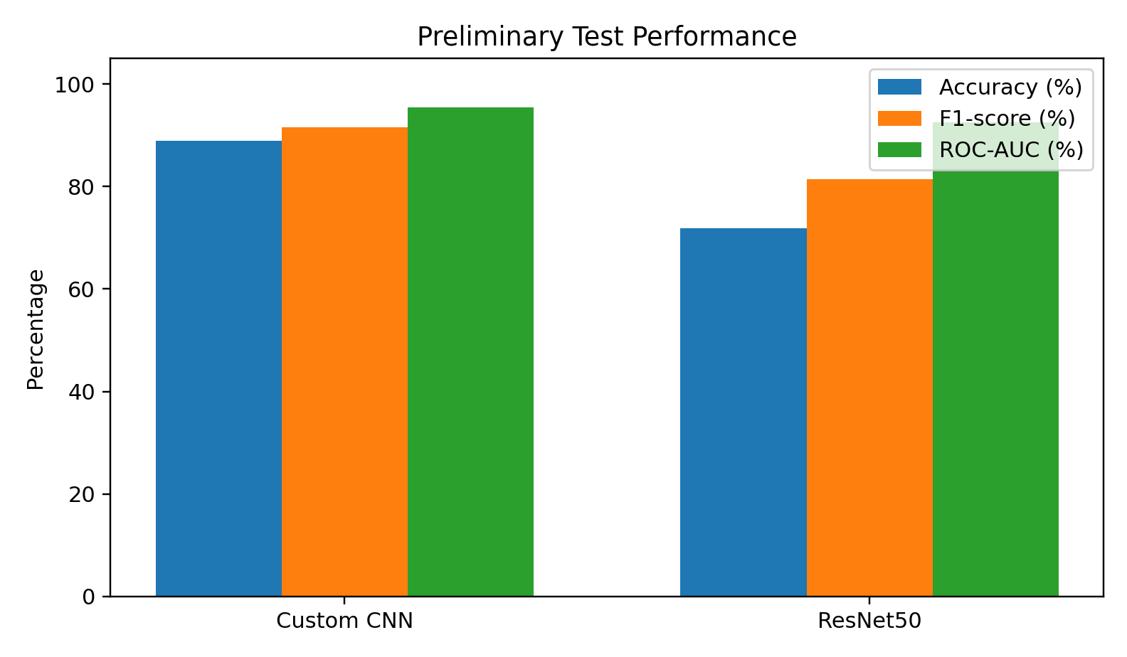
Figure 3. Comparison of preliminary test metrics for the two implemented models.
9.1 Custom CNN Confusion Matrix and Classification Report
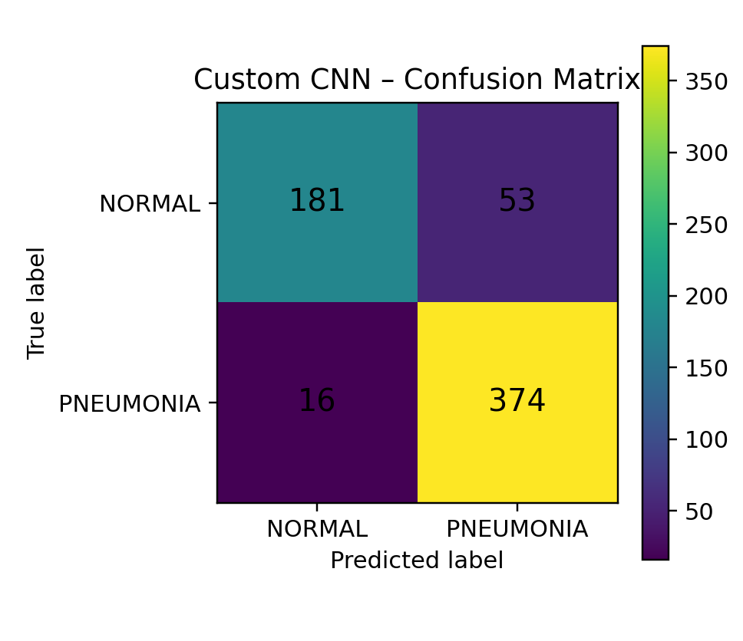
Figure 4. Custom CNN confusion matrix.
Class / average | Precision | Recall | F1-score | Support
NORMAL | 0.9188 | 0.7735 | 0.8399 | 234
PNEUMONIA | 0.8759 | 0.9590 | 0.9155 | 390
Accuracy |  |  | 0.8894 | 624
Macro average | 0.8973 | 0.8662 | 0.8777 | 624
Weighted average | 0.8920 | 0.8894 | 0.8872 | 624

The Custom CNN produced 181 true NORMAL predictions, 53 NORMAL images incorrectly classified as PNEUMONIA, 16 PNEUMONIA images incorrectly classified as NORMAL, and 374 true PNEUMONIA predictions. The ROC-AUC of 0.9544 indicates good ranking performance on this test split, but it should not be interpreted as clinical validation.
9.2 ResNet50 Confusion Matrix and Classification Report
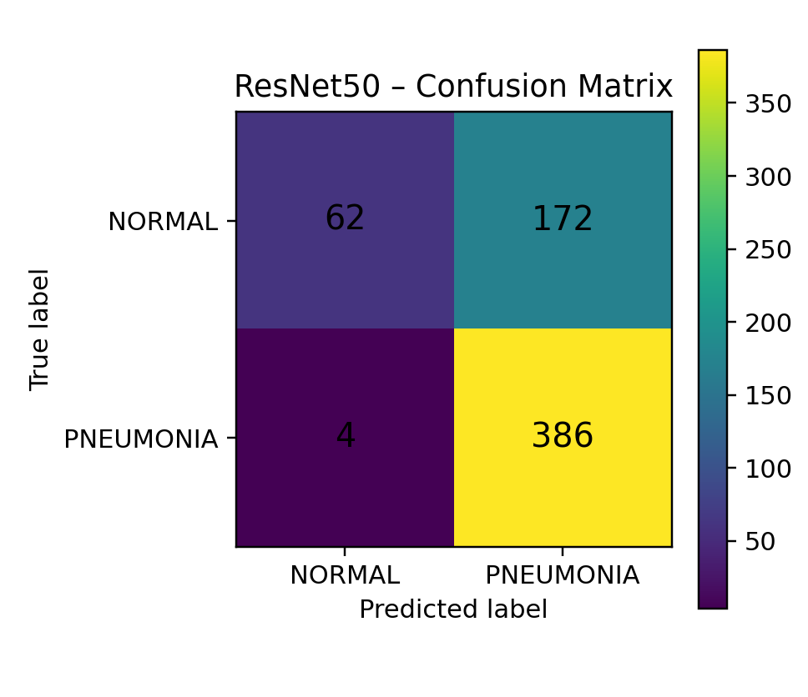
Figure 5. ResNet50 confusion matrix.
Class / average | Precision | Recall | F1-score | Support
NORMAL | 0.9394 | 0.2650 | 0.4133 | 234
PNEUMONIA | 0.6918 | 0.9897 | 0.8143 | 390
Accuracy |  |  | 0.7179 | 624
Macro average | 0.8156 | 0.6274 | 0.6138 | 624
Weighted average | 0.7846 | 0.7179 | 0.6640 | 624

The frozen-base ResNet50 predicted 386 PNEUMONIA images correctly and only 62 NORMAL images correctly. It therefore achieved very high PNEUMONIA recall (98.97%) but substantially lower NORMAL recall (26.50%), with 172 NORMAL images classified as PNEUMONIA. This pattern indicates that the current frozen transfer-learning baseline has not yet learned a sufficiently balanced decision boundary for this dataset.
9.3 Preliminary Interpretation
The Custom CNN provides a stronger current baseline on overall accuracy, PNEUMONIA F1-score, and ROC-AUC in this experiment.
The ResNet50 baseline has very high PNEUMONIA recall but a large number of NORMAL-to-PNEUMONIA errors, which reduces accuracy and F1-score.
The ResNet50 result should not be treated as evidence that ResNet50 is intrinsically unsuitable. The present experiment freezes the pretrained backbone and uses a simple classifier head; controlled fine-tuning, class balancing, learning-rate scheduling, and other preprocessing choices remain to be evaluated.
Because the models were trained and tested on the same public benchmark split, the results describe this experimental setting only. External generalization is not established.
The remaining DenseNet121 and ViT models are necessary before the planned four-architecture comparison is complete.
10. Software and Experimental Environment
Component | Current configuration
Operating system | Windows
IDE | Visual Studio Code
Python | 3.13.16
Deep learning framework | TensorFlow 2.21.0
Notebook kernel | DL Mini Project / Python 3.13.16
Core libraries | NumPy, Pandas, Matplotlib, Seaborn, scikit-learn, Pillow, OpenCV
Dataset input | JPEG chest X-ray images
Image size | 224×224
Batch size | 32

The project is organized into dataset, notebooks, models, preprocessing, report, and results directories. The current notebooks include dataset exploration, preprocessing, Custom CNN, and ResNet50 experiments.

Git / Commit History

